Hotel Booking Chat Bot:

We want a bot to assist customers with hotel reservations. The bot should enable customers to search for available rooms, book rooms using a room ID, check booking status, and cancel reservations. Each reservation will be indexed using a Reservation ID.

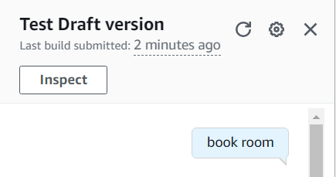
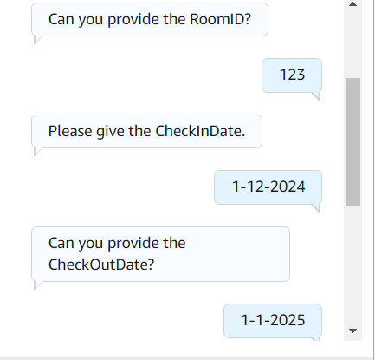
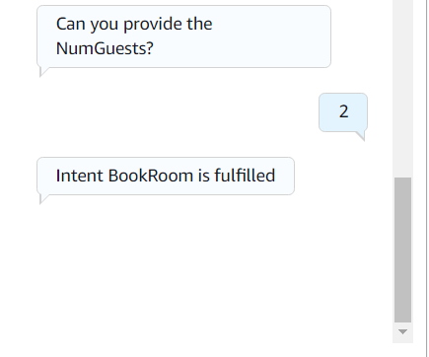

Flight Chat Bot:

We aim to create a bot that helps customers with travel bookings. The bot should allow customers to search for available flights, book flights using a flight ID, check the status of their bookings, and cancel bookings. Each booking will be indexed using a Booking ID.
